**Duong Le**

**IT 360**

**Pages: Card, List types and Action Controls**

**Card Page as shown below**

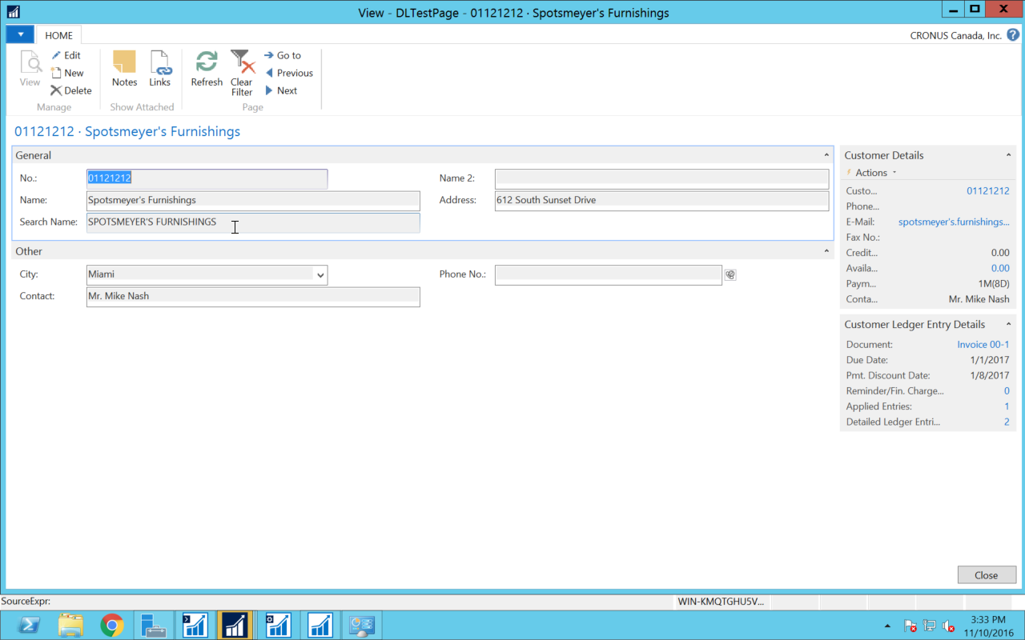

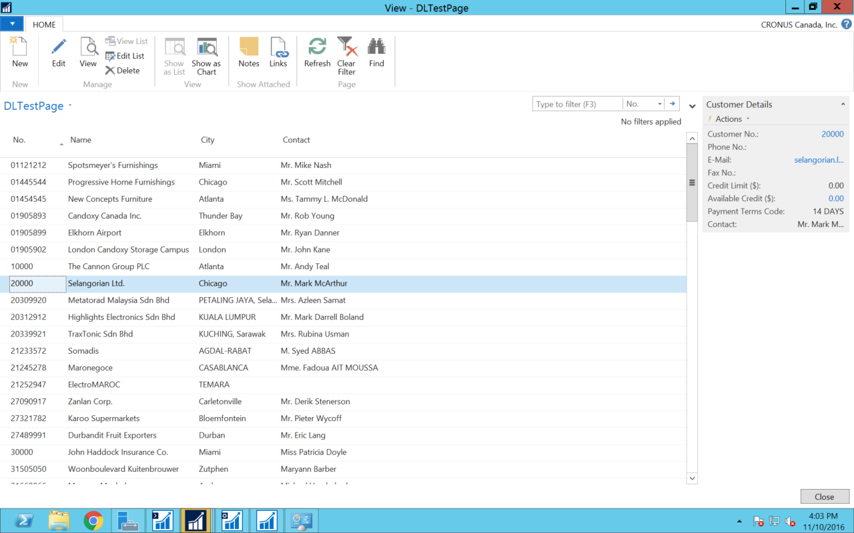 **List Page as shown below**

**Page Action Controls as shown below**

